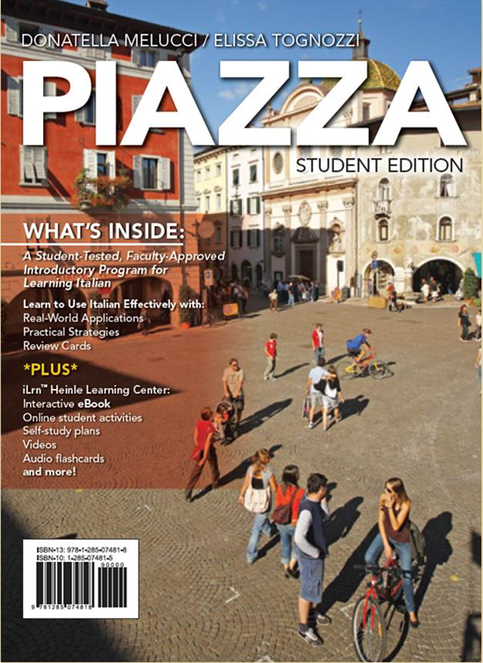
Piazza: Luogo di incontri authored by Donatella Melucci and Elissa Tognozzi. This introductory-level program addresses the needs of beginning learners of Italian with an enriching language learning experience through communicative and thoughtful practice, innovative instructional design, robust technology integration, and a wide range of cultural coverage. It employs an intuitive and functional approach to proficiency development, with research-driven strategies to include cultural awareness, literacy development, and difficult sentence structures.

Click here for a Prezi presentation

Or copy this link into your browser for a PREZI presentation
http://prezi.com/270rc8fwcem8/piazza-luogo-di-incontri/?utm_campaign=share&utm_medium=copy

